**Milestone 2**

**Housing AI**

**March 3, 2024**

**Isaac Royal, Essence Ochoa,**

**Chelsa Lowery**

1. **Meeting minutes (GitHub) (Submitted in GitHub)**
2. **Work Breakdown Structure (WBS).** Create a WBS describing your process for creating this project. Use realistic time estimates.

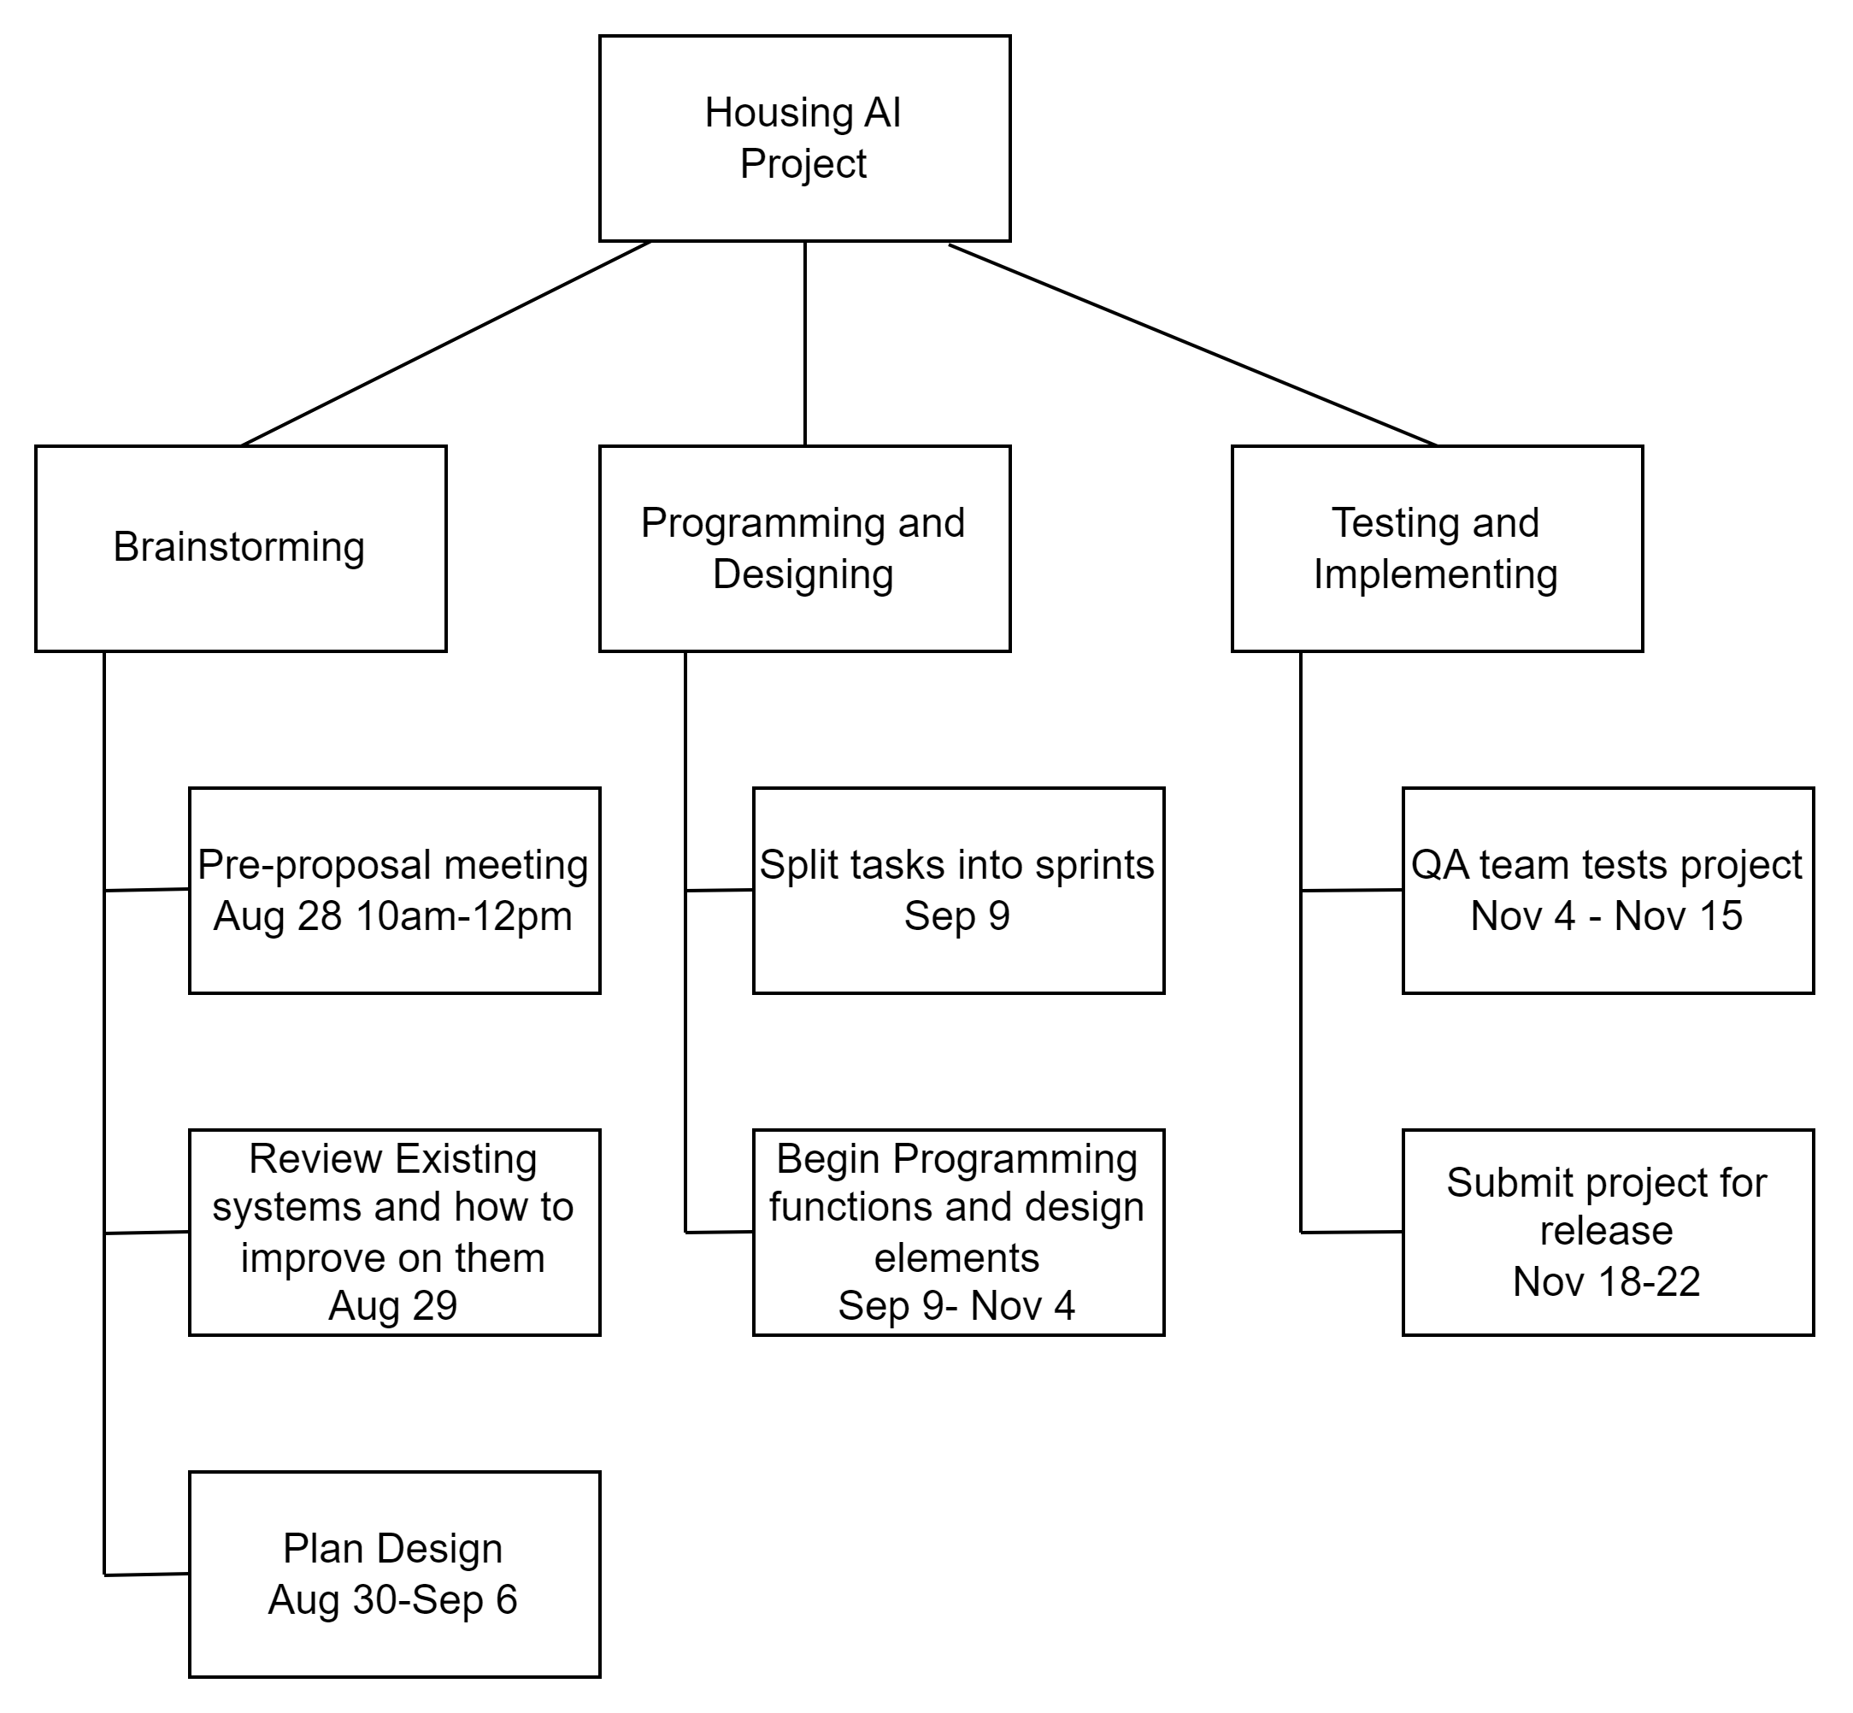

1. **Gantt Chart & Network Diagram.** Create this based on your WBS.

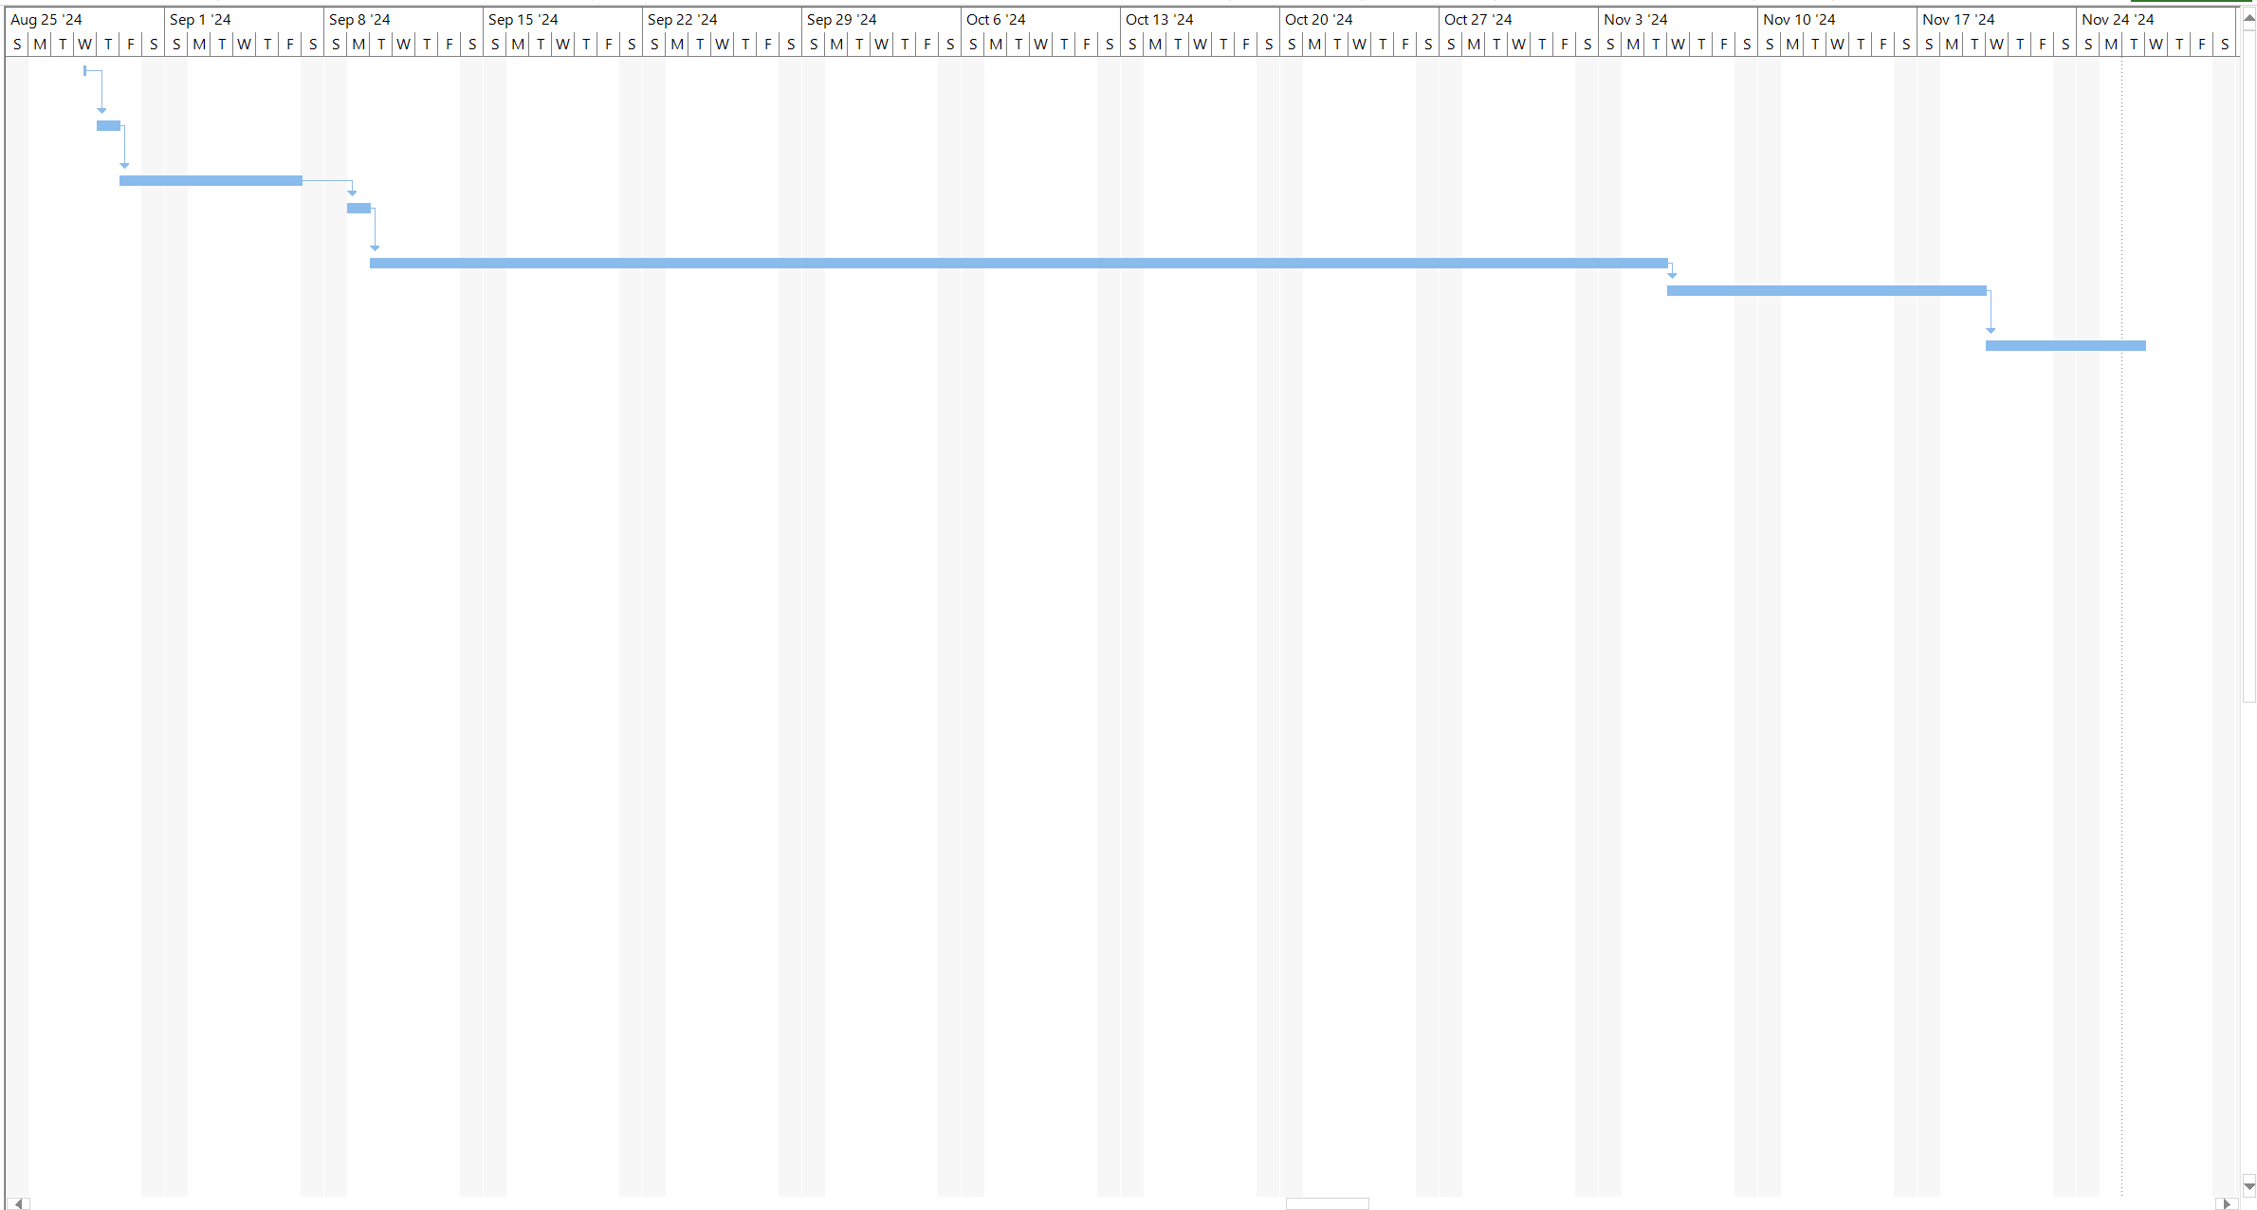

1. **Detailed Requirements Document.** List all functional and non-functional requirements of the system.
2. **Fully Dressed-Use Cases.** Create use cases like those covered in the reading and assignment.
3. **Use Case Diagram.**
4. **Research on other systems.** Research similar systems and describe their design and capabilities. The system does not need to be an app or directly related to the topic but uses similar functionality.
5. **API Descriptions.** Describe all APIs you expect the system to interact with (ie. Google Maps).

## **Requirements**

### **Functional Requirements:**

1. **Data Entry and Storage:**
   * Housing AI will let users enter their information such as location, house type, and price range to find a home suitable to their needs.
   * All data entered will be placed into the Housing AI Database and will be used to provide a smoother process based on the location entered.
2. **Search and Retrieval:**
   * Housing AI will integrate the Housing Market into all search-based functions.
   * Housing AI will allow users to retrieve relevant data efficiently and in a user-friendly format.
3. **Reporting:**
   * Monthly updates and reports will be provided to the users on company progress and frequent changes in the Housing Market
   * Housing AI will allow users to customize and export reports in various formats (e.g., PDF, Excel) for further use and sharing.
4. **User Authentication and Authorization:**
   * Two step authentications will be made a point of emphasis for our agents, employees, and users to keep all sensitive information safe.
   * Housing AI will allow administrators and IT managers to manage user roles and permissions.
5. **User Interface:**
   * Housing AI will provide an intuitive and user-friendly interface for easy navigation and interaction.
   * Housing AI will be accessible on multiple devices (desktops, tablets, smartphones) to accommodate varying user preferences.

### **Non-Functional Requirements:**

1. **Performance:**
   * Housing AI will provide each user with an optimal experience that ensures their search for a home is as smooth as possible.
   * Housing AI will also ensure that our real estate agents and partners can use our system to better their knowledge and specific research on the Housing Market.
2. **Security:**
   * Using contracting services and our in-house analyst, a strong foundation of cybersecurity will be made a crucial point of interest to ensure sales and performance are not affected.
   * Two step authentications will be made a point of emphasis for our agents, employees, and users to keep all sensitive information safe.
3. **Scalability:**
   * Improvements will be made constantly to keep up with the growing changes in technology and the ever-changing Housing Market.
4. **Reliability and Availability:**
   * Improvements will be made to ensure the Housing AI has cloud-based reliance and less hardware stationed in multiple offices.
   * Housing AI will be aiming for users to have access to our services 24 hours every day. On-call IT representatives will be available during these times to answer questions and provide support on any issues that may arise.
5. **Compliance:**
   * Housing AI will adhere to relevant data privacy and security regulations, ensuring compliance with local and international laws.
   * Housing AI will adhere to all ADA Compliance Regulations.
6. **Language and Localization:**
   * Housing AI will support all languages and adhere to all disabilities through our accessibility services.
   * All users will have the ability to select their preferences regardless of the device they own.
7. **Cultural Sensitivity:**
   * Housing AI will not tolerate any forms or acts of racial, gender, or disability discrimination within our services.
   * Housing will incorporate diverse perspectives and sensitivities related to gender, ethnicity, and cultural practices in its design and content.
8. **Inclusivity and Diversity:**
   * The system will embrace inclusivity by accommodating various cultural perspectives, traditions, and beliefs, ensuring that the platform is accessible and welcoming to all users, regardless of their cultural backgrounds.
   * The system will avoid any discriminatory practices, biases, or stereotypes based on cultural attributes or backgrounds.
9. **User Training and Cultural Sensitization:**
   * Housing AI will include training modules that educate agents, representatives, and analysts on the current state of the Housing Market and all problems we face with growing technology.
   * Housing will promote cultural awareness and understanding among users to enhance communication and collaboration within the platform.
10. **Community Involvement:**
    * Housing AI will constantly put out monthly surveys and reports to users to receive feedback and provide information on future endeavors and plans.
    * Housing AI will collaborate with other companies and organizations, such as Zillow, to better improve our services and performance in the Housing Market.

## **Research on Other Systems**

Daud, F. (2020, January 22). *Building a data streaming platform - how Zillow sends data to its data lake*. Zillow. <https://www.zillow.com/tech/building-a-data-streaming-platform/>

*About HousingIS*. HousingIS. (n.d.). <https://housingis.org/about>

*We are chronos.* About | Chronos Interactive. (n.d.). <https://www.chronosinteractive.com/about>

## **API Descriptions**

Our application program interface allows us to use Artificial Intelligence to combine the user information and updated information on the Housing Market to provide users with the best possible Housing preference. The steps involve in this process include:

1. Obtain information from users such as location, pricing, living circumstances, and other preferences.
2. The system enters this information into our Database for future reference and current application.
3. Using Artificial Intelligence, our programmers, analysts, and engineers can isolate user preferences and group all responses based on relatability.
4. All preferences are then put into a Housing Market Program that finds all relevant homes and generates them into a list.
5. Once the list is fully created, results are displayed to the user through mobile or web application where they can continue their search for their ideal home.